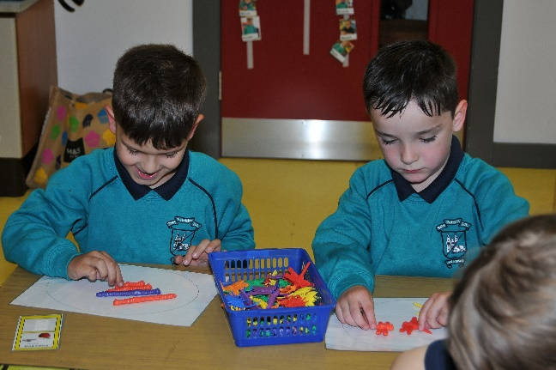
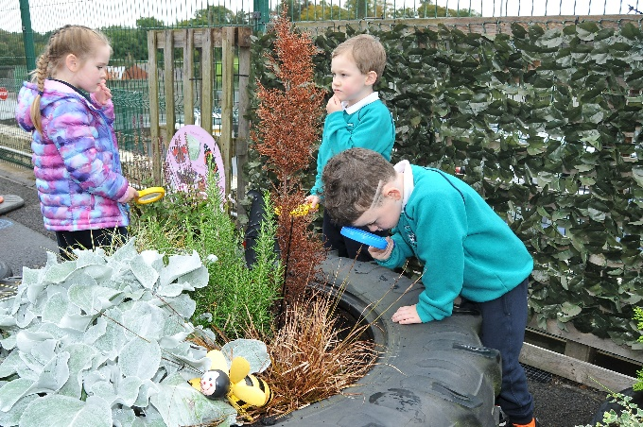

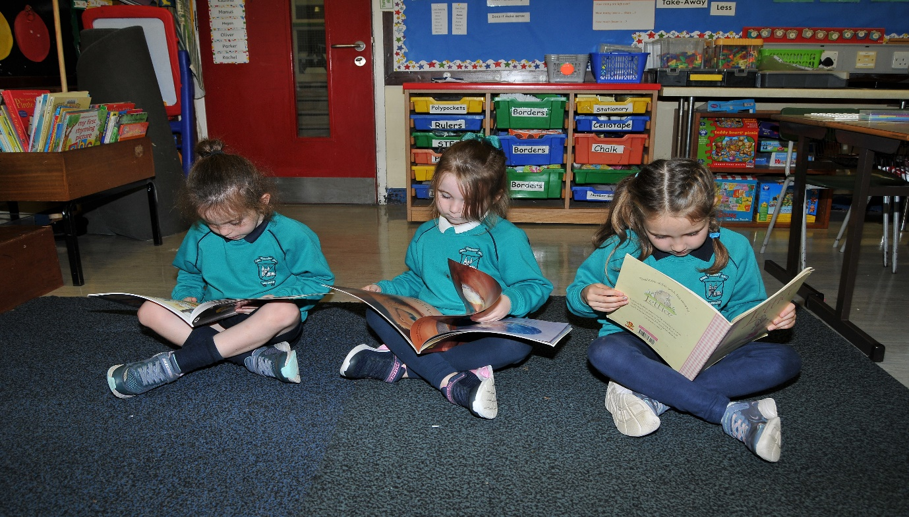
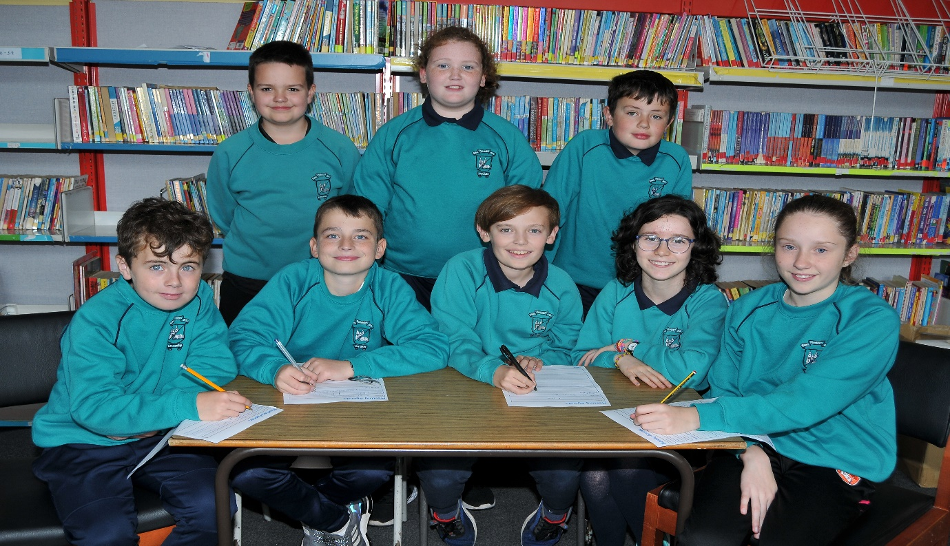
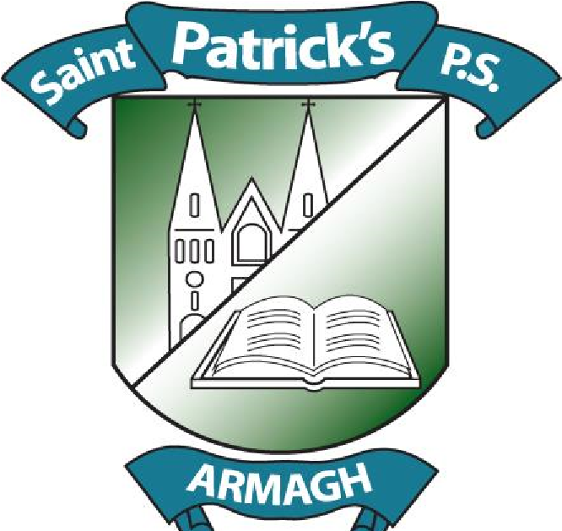
St Patrick’s Primary School issue invite to prospective pupils and their parents to their Open Days

St Patrick’s Primary School on the Loughgall Road, Armagh is preparing to welcome prospective Primary 1 pupils and their parents to our Open Days which will take place next week from 1.30 – 3.00pm on both Wednesday 10 and Thursday 11 January 2024.
Our Open Days provide prospective parents with the opportunity to come along and visit the school, to meet with staff and to ‘get a sense’ of what it is like to be a pupil within our school.
As a school that prides itself as being at the very heart of the community we serve, we value our relationship with parents and this invite to come along provides us with the opportunity to establish this link and provide a glimpse of everything that is great about our school as we seek to continue to build the community within our school.
For many of the children who will hopefully come along, this will not be the first time they have visited our school as, due to the strong working relationships we have with our pre-school colleagues, many of the children would have attended one of our ‘Fun-da-mental Days’ at the beginning of December where we invite our local nursery schools to visit for a morning of fun and activity.
St Patrick’s strives to be a school where, each day, children feel happy, safe and secure in the knowledge that they are cared for, valued and respected.
Celebrating over 50 years of educational excellence in 2019, St Patrick’s prides itself on our rich educational history, while continuing to drive forward at the forefront of education, with the key aim of providing a high-quality education for all our children in preparing them to be lifelong learners.
For our Governors and staff, the child sits at the very centre of everything we do and this is reflected in our Christian, Catholic ethos that promotes the enrichment of pupil life where all our pupils are immersed in a caring, supportive learning environment and provided with a wide and varied range of opportunities to grow in love, confidence, self-esteem and self-worth.
Our school prides itself on our reputation for high expectations and standards, whilst always looking to develop the ‘whole child’ in realising their full potential across all disciplines- academic, sporting, artistic and creative.
Building on our mutually beneficial relationship with our parents and the local community, our school plays a central role in working in partnership to support our families, our local area and our parish.
In living up to our school’s mission statement – ‘We Care, We Share, We Learn’, we continually look to also build our school within the community through regular fundraising initiatives for local and national charities; participating in locally held events; visiting care homes and working closely with those within the community for the benefit of all.
As we begin the new calendar year, we look forward to opening our doors for the visit of existing parents connected to our school, but especially those parents, who along with their child, have reached a further new milestone – the beginning of their primary school journey.

